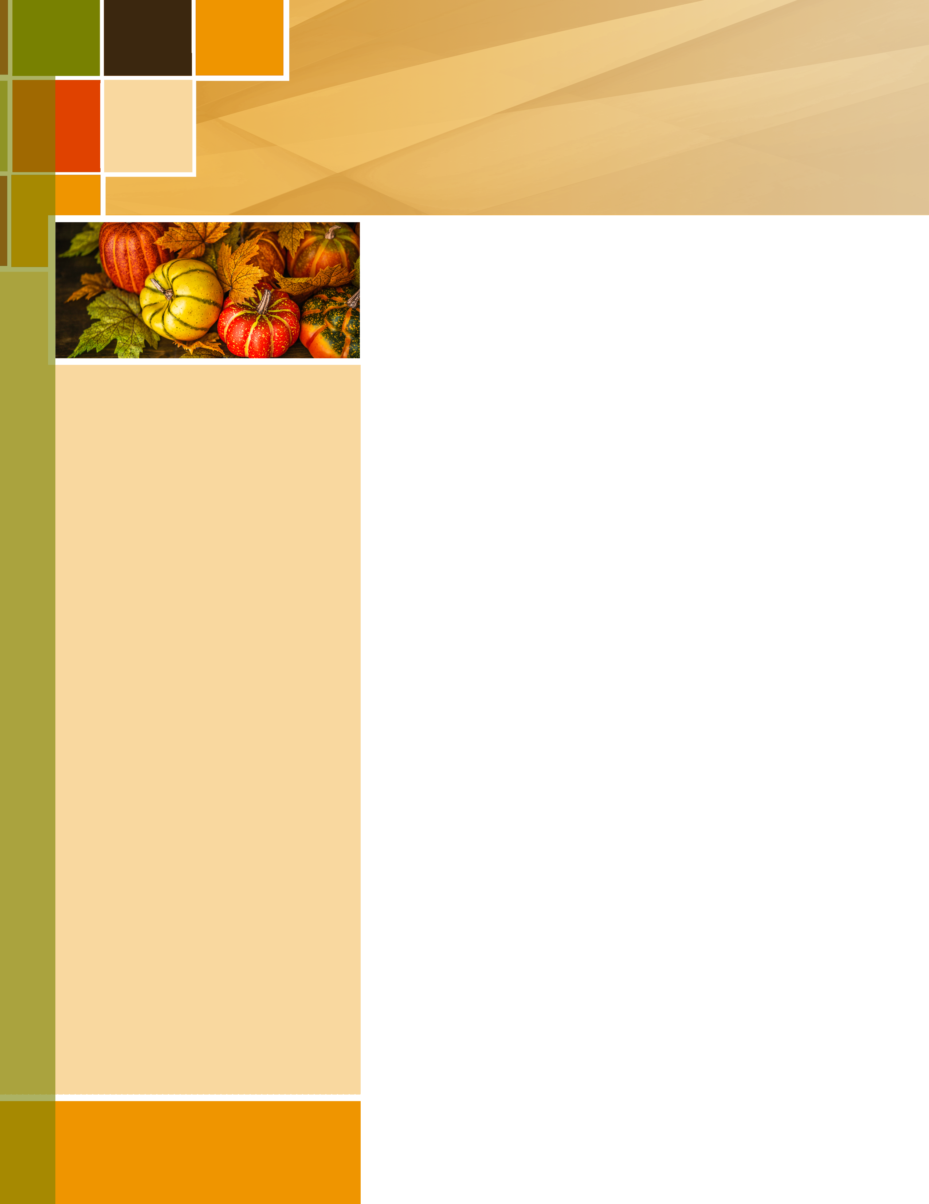
OCTOBER 2017

Tranquility Times
Tranquility Estates * 4069 E Cook Road, Grand Blanc * 810-771-7754 * www.tranquility-estates.com
Celebrating October  The Flag Raising Ceremony at Tranquility  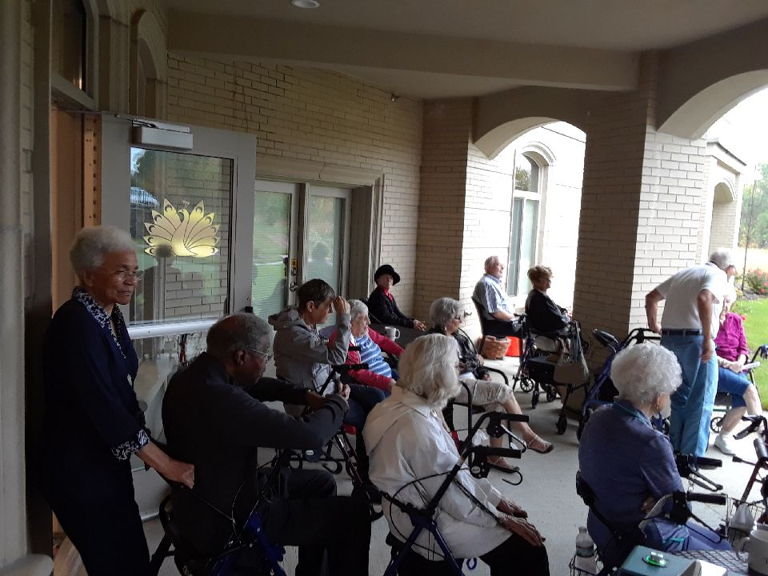  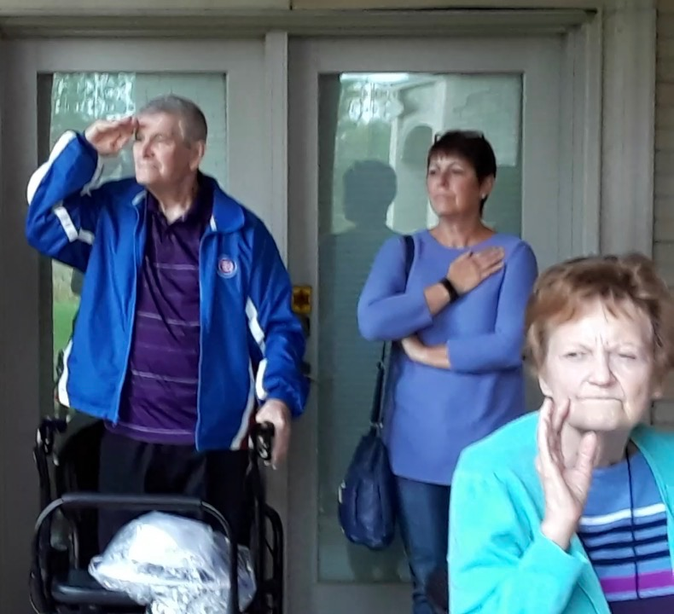 | Warm Heart of the Month – October  “To give real service you must add something which cannot be bought or measured with money, and that is sincerity and integrity.”  Jamika Cain  Thanks, Jamika, for always being there for  our residents! Your dedication is an inspiration to us all! We appreciate all that you do here at Tranquility Estates.

October 2017  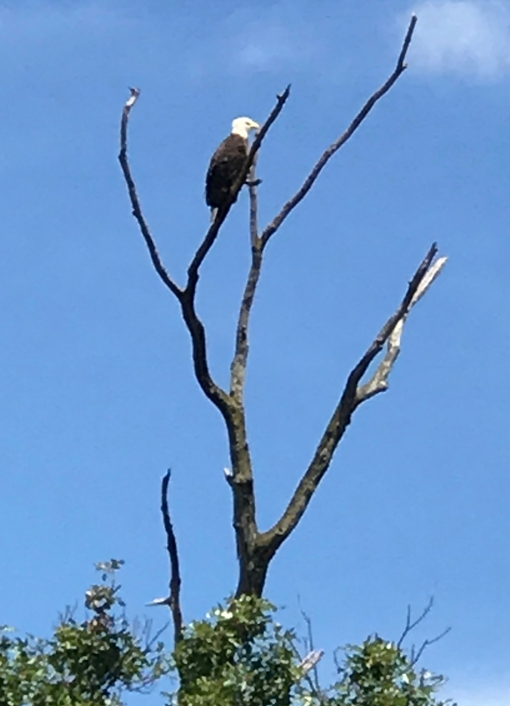From Eagle Sighting to putting on the new putting greens, summer was full of activity. Ed probably spent more time on the green than anyone!  And beachball volleyball became one of the most popular indoor sports. Lots of laughs and giggles!  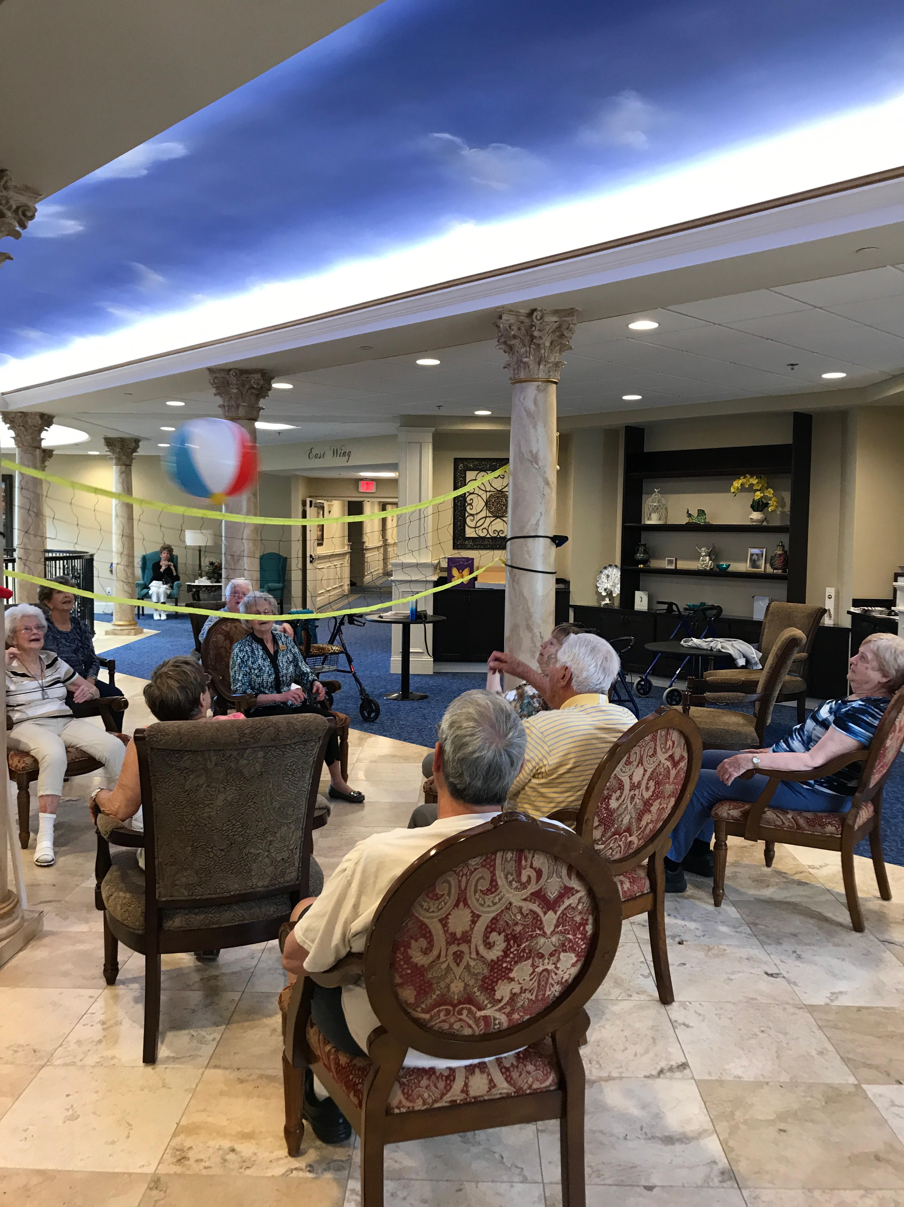 | Saying Goodbye to the Summer  This summer we spent lots of time outdoors.  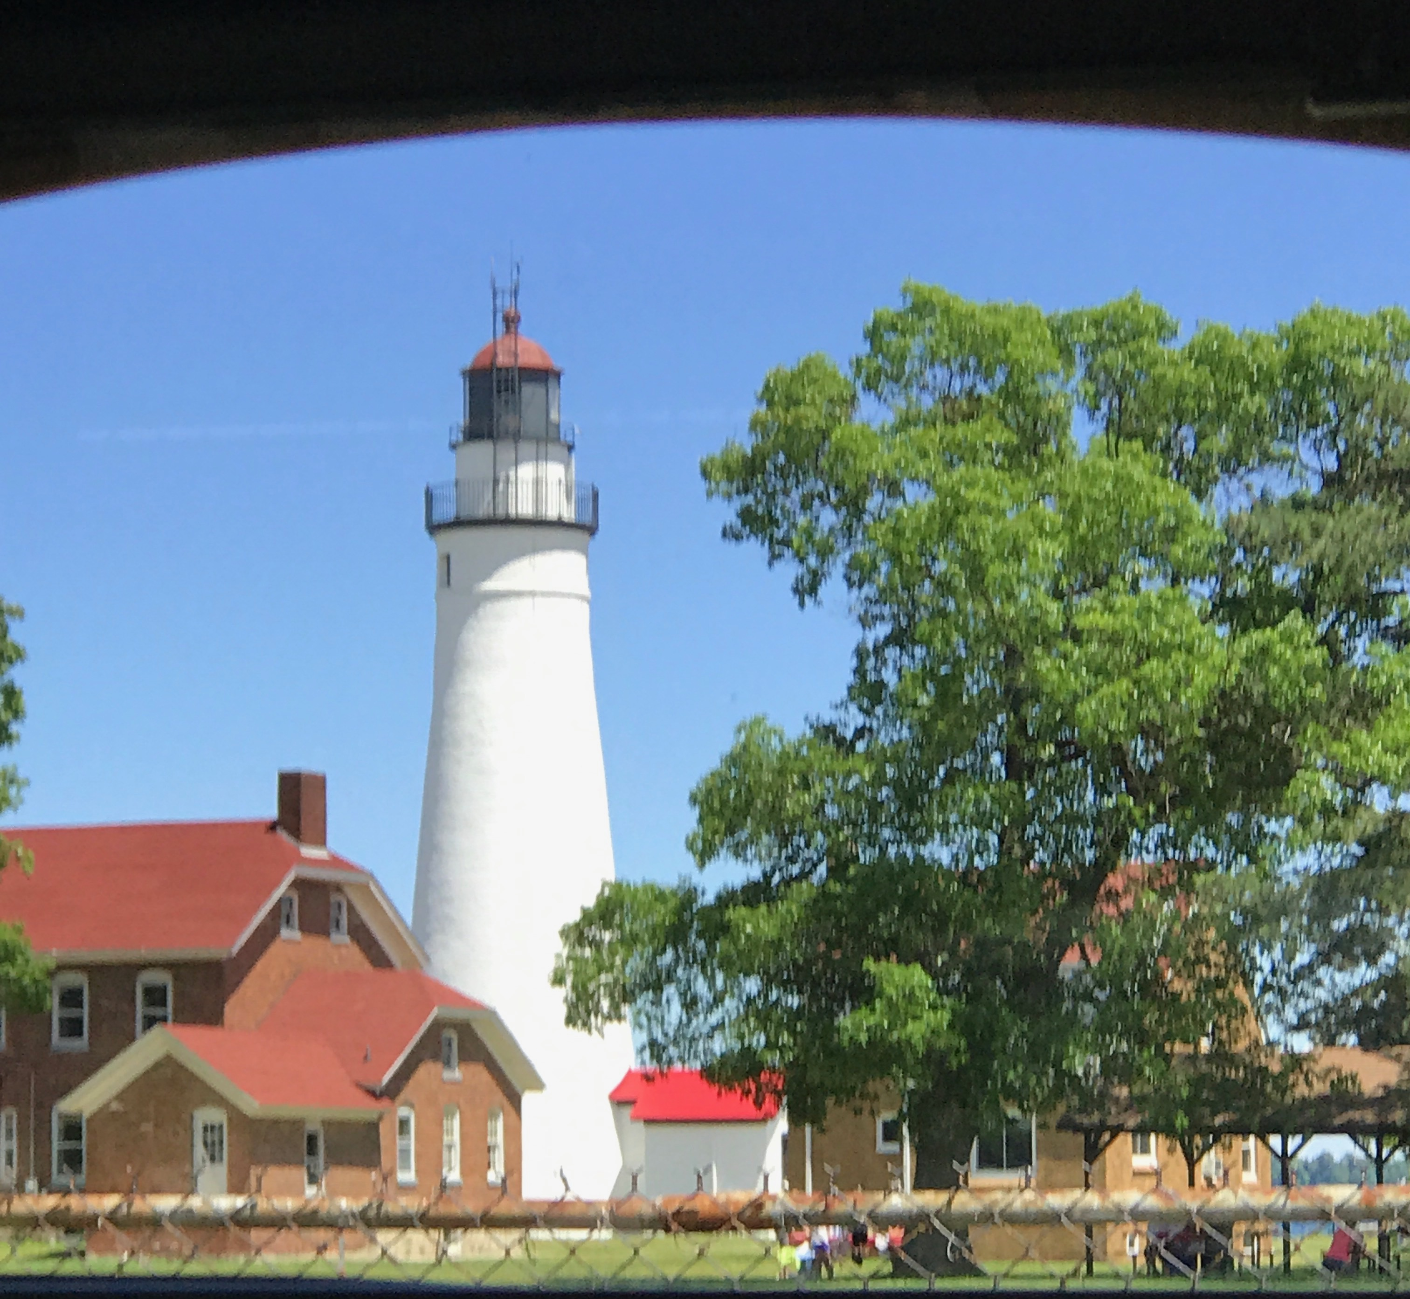  One of the nicest trips we took was the one to Port Huron!  Straight to the Top  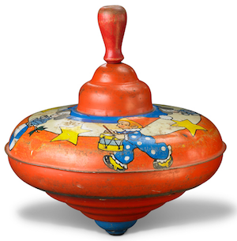  For many, the idea of spinning  in one place is enough to make them dizzy, but that’s  the whole purpose behind International Top Spinning  Day on October 12. Tops  are some of the oldest known toys in the world. Archaeologists discovered clay tops buried in  the ruins of the ancient city of Ur in Mesopotamia, dating back to 3500 BC. Why is the motion of a spinning top so engrossing? Is it because it appears to defy gravity? Are we naturally attracted to the way it spins just like Earth rotates on its axis? This gravity-defying spin, known as the gyroscopic effect, is an impressive  motion that uses inertia, gravity, momentum, and  centrifugal force to stay balanced and upright.  Of course, every top falls over eventually, thanks to the friction between its spinning point and the surface it is spinning on. But it was Iacopo Simonelli who made his homemade top spin for over 40 minutes with a single twist of the fingers. Humankind has certainly come a long way from spinning acorns and pennies.
October 2017  Nightmares and Moonlight  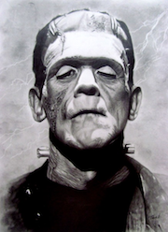  In the spooky spirit of the Halloween season, the last Friday in October is known  as Frankenstein Friday, after Mary Shelley’s fictional novel about a mad scientist who created a monster. More interesting than the fiction  are the facts surrounding why Shelley set out  to write her gothic masterpiece.  In June of 1816, the 18-year-old Shelley was invited to Geneva, Switzerland, along with the poet (and her future husband) Percy Bysshe Shelley, her stepsister Claire Clairmont, the poet Lord Byron, and Lord Byron’s doctor (and writer  of vampire stories) John Polidori. On a rather cliché dark and stormy night, after reading from  a volume of German ghost stories, Lord Byron challenged all the guests present to write their own scary tale. It was out of this challenge that Mary Shelley penned Frankenstein.  In a preface to her book written in 1831,  Shelley wrote about how she suffered from a  lack of ideas. After staying up late philosophically discussing “the nature and principle of life,” and how one Dr. Erasmus Darwin had attempted  to make dead matter move by administering elecrical jolts, Shelley fell asleep only to be hounded by a nightmare: a man attempting to breathe life into a terrifying figure. She awoke with a start to find bright moonlight streaming  in through her window. She realized that if the dream had frightened her, then it would frighten audiences. On the next morning she began writing Frankenstein. Of all the writers present, only Shelley finished her novel.  Mary Shelley’s Frankenstein has become  world-famous and is lauded as the first science fiction story ever written. It is also a philosphical masterpiece, examining the relationship between creator and created, and forcing us to wonder how much knowledge is too much. And of course, it is important to remember that Frankenstein is the name of the doctor,  not the monster that the doctor created. | All Hail the Kale  October 4 of this year heralds the fourth celebration of Kale Day. Kale, sometimes called “the king of leafy vegetables,” is full  of health benefits. It is also easy to cultivate, growing from spring all the way into winter, when frosts actually make kale sweeter. But kale has become more than a vegetable; it has achieved cult status, complete with T-shirts, bumper stickers, and celebrity endorsements. When did kale become popular? When public relations guru Oberon Sinclair decided it should, that’s when. The savvy PR woman made kale cool when she got the trendiest restaurants and celebrities to endorse the leafy green. She even went so far as to create the fictitious American Kale Association to lend her advertising campaign credibility. But we can forgive Oberon for duping us with such sneaky tactics. Kale, after all, is a healthy vegetable. And she did it not for the money or the fame,  but because she loves kale. Oberon’s movement gained such a following that Columbia University Professor Dr. Drew Ramsey founded the first Kale Day in 2013, giving us all reason to “kale-abrate.”  Mistaken Invasion  It was on October 30, 1938,  a Sunday evening and prime time for listening to the radio, that Orson Welles broadcast H.G. Wells’ science fiction story The War of the Worlds,  a dramatization of a Martian invasion of Earth. No one anticipated that the story would cause a national panic. The broadcast began with  an innocuous weather report and live music, which was interrupted with a news report detailing the sudden invasion of Earth by hideous aliens. When the actors realistically announced that Martians were wiping out major cities, listeners flew into a panic. As many as  a million people believed the invasion was real. Welles thought the controversy would ruin his career, but the wild performance earned him  a Hollywood contract and superstardom.
Light and Prosperity  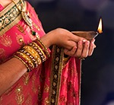  Diwali, India’s most important holiday of the year, begins on October 19. The Diwali story differs depending on where  in India you live. In the north  of India, it celebrates the return  of the warrior prince Lord Rama to the ancient city of Ayodhya after he defeated Ravana, the king of the demons, by lighting rows of clay lamps. Southern India celebrates it as the day Lord Krishna, the god of love and compassion, defeated the demon Narakasura. In Western India, Diwali marks the day that Lord Vishnu,  one of Hinduism’s main gods, the Preserver of  all earth from destruction, sent the evil King Bali, who had conquered the heavens, to rule over the underworld. Each of these three stories highlights the most important lesson of Diwali: the victory of good over evil and of light over darkness. This  is why Diwali is known as the Festival of Light.  There is another key piece of Diwali. It originally coincided with the last harvest of the year before  the onset of winter and darkness. On this day, farms and businesses begged for blessings  from Lakshmi, goddess of wealth, for the new financial year. This is why the day after the last day of Diwali is still considered the beginning of the new fiscal year for all businesses in India.  Diwali lasts for five days. Families typically  spend the first day cleaning the house and honoring Lakshmi, the goddess of wealth, by buying gold, silver, and other luxury items. That night, the ritual lamps are first lit. On the second day, families decorate the floor of their homes with colorful patterns made of sand and powder called rangoli. The designs reflect local traditions and beliefs. The third day is the main holiday, Diwali night, and falls on the darkest night of the new moon. Lamps are lit and doors are opened  to encourage Lakshmi to enter. Friendships are celebrated, sweets are shared, and fireworks  are set off. The fourth day is a celebration of marriage, and the fifth day is a celebration of brothers and sisters, a way of strengthening family ties. At the end of Diwali, the lights may  go out, but the darkness is conquered. | October Birthdays  In astrology, those born from October 1 to 22 balance the scales of Libra. Libra epitomizes fairness and harmony in all dealings large and small. Sincere, beautiful, and romantic, Libra will work hard to keep all relationships on an even keel with boundless grace and charm. Those born between October 23 and 31 are Scorpios. Scorpios are passionate, deep, and intense, qualities that help them counsel others  in deep and meaningful ways. Resourceful and determined, Scorpios give their all when it comes to following their hearts.  Julie Andrews (actress) – October 1, 1935  Ray Kroc (entrepreneur) – October 5, 1902  Jesse Jackson (activist) – October 8, 1941  Luciano Pavarotti (singer) – October 12, 1935  e. e. cummings (poet) – October 14, 1894  Evel Knievel (daredevil) – October 17, 1938  Johnny Carson (TV host) – October 23, 1925  Pablo Picasso (artist) – October 25, 1881  Sylvia Plath (writer) – October 27, 1932  Bill Gates (billionaire) – October 28, 1955  pleading the case  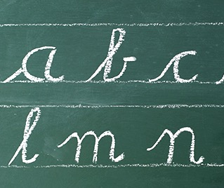  these small letters aren’t an editing mistake. october 14 is lowercase day. originally, alphabets were written entirely in uppercase, or capital, letters. when written quickly and in succession, these large letters were confined to the upper and lower lines of the page and easy to read. then writers got fancy, creating letters that flowed over and under the lines. it is from these fancy letters that writers developed the first lowercase letters, which became popular and were adopted by writers throughout europe. the term lowercase developed much later from manual typesetting. because lowercase letters were used more often, they were kept in a “lower case” within easy reach of the typesetter. the capital letters were held farther away in an “upper case.” has your appreciation of lowercase letters changed as a result of reading this paragraph?
October 2017

